

**CS-114 - Fundamental of Programing**

**Lab Manual # 4**

**Lab Task**

Submitted To: Muhammad Affan

Submitted By: Shahzaib Murtaza (466034)

Section: B

1. **Write a program in C++ to find the sum of first 10 natural numbers.**

#include <iostream>

using namespace std;

int main(){

int n=0;

for (int i=1; i<=10; ++i) {

n=n+i;

}

cout<<n;

return 0;

}

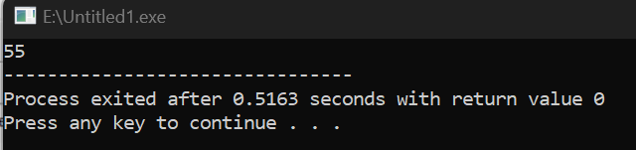

1. **Write a C++ program to Print a Table of any Number.**

**The output should look like this:**

#include <iostream>

using namespace std;

int main(){

int f=0;

for(int i=1; i<=10; ++i ){

f= 2*i;

cout << "2x"<<i<< "="<<f<<endl;

}

return 0;

}

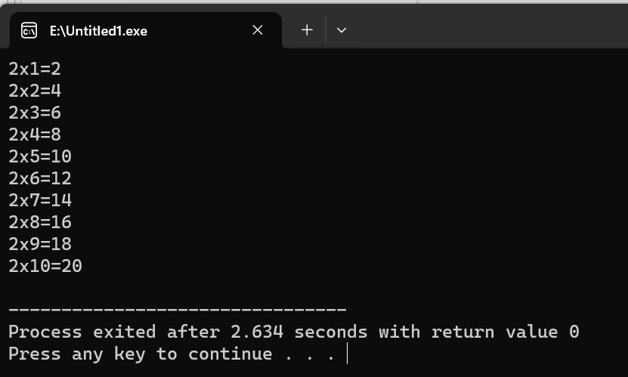

1. **Write a Program to Generate Factorial. A Certain Number Factorial of any number is the product of an integer and all the integers below it for example factorial of 4 is: 4! = 4 * 3 * 2 * 1 = 24**

#include <iostream>

using namespace std;

int main(){

int factorial=1, number;

cout<< "Enter Number:";

cin>> number;

for (int i; i<= number; i++){

factorial=factorial*i;

}

cout<< "Factorial:" <<factorial;

return 0;

}

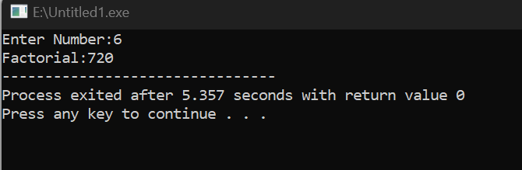

1. **Write a C++ program to generate a Fibonacci sequence up to a certain number input by the user.**

#include <iostream>

using namespace std;

int main(){

int value1,value2,value3, sum=0;

cout<<"Enter First Value:";

cin>>value1;

cout<<"Enter Second Value:";

cin>>value2;

cout<<"Enter Stopping Value: ";

cin>>value3;

do{

if(value1==0 && value2==1){

sum=value1+value2;

cout<<value1<<","<<value2<<",";

}

sum=value1 + value2;

cout<<sum<<",";

value1=value2;

value2=sum;

}

while(sum<value3);

return 0;

}

